

_________________________________________________________________

Name: HIDAYAT ULLAH

Roll: B24F0050AI099

Dep: BS AI

SUBJECT: DLD LAB TASK

Submitted to: Mr. SYED RAGHIB RAZA BUKHARI

**Experiment 1**

**Introduction to Digital Laboratory Equipment & ICs**

**Objective**

• To familiarize with the equipment and to use the ICs.

# Tools/Equipment Requirement

* Digital Trainer
* IC 7404 NOT Gate

# Theoretical Explanation

**The Breadboard**

The breadboard consists of two terminal strips and two bus strips (often broken in the centre). Each bus strip has two rows of contacts. Each of the two rows of contacts are a node. That is, each contact along a row on a bus strip is connected together (inside the breadboard). Bus strips are used primarily for power supply connections, but are also used for any node requiring a large number of connections. Each terminal strip has 60 rows and 5 columns of contacts on each side of the centre gap. Each row of 5 contacts is a node.

You will build your circuits on the terminal strips by inserting the leads of circuit components into the contact receptacles and making connections with 22-26 gauge wire. There are wire cutter/strippers and a spool of wire in the lab. It is a good practice to wire +5V and 0V power supply connections to separate bus strips.

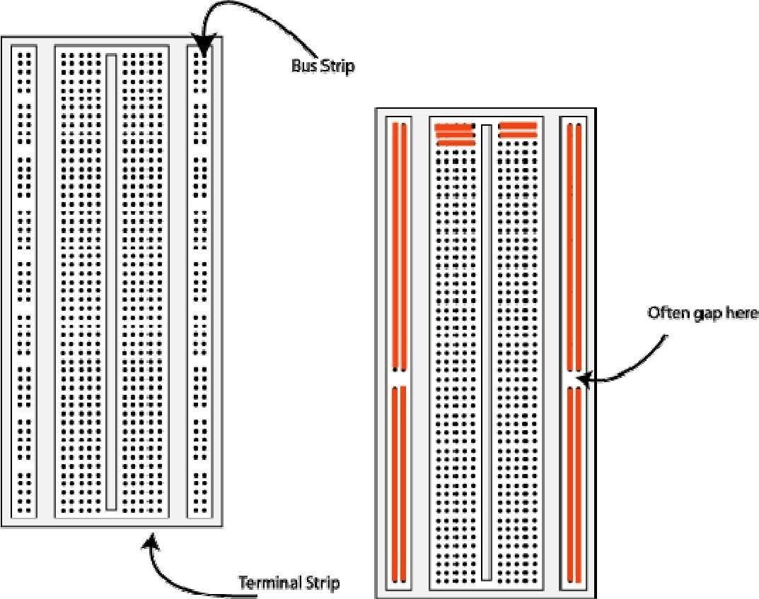

**The breadboard. The lines indicate connected holes.**

The 5V supply **MUST NOT BE EXCEEDED** since this will damage the ICs (Integrated circuits) used during the experiments. Incorrect connection of power to the ICs could result in them exploding or becoming very hot - with the **possible serious injury occurring to the people working on the experiment! Ensure that the power supply polarity and all components and connections are correct before switching on power.**

# Procedure

**Building the Circuit**

1. Throughout these experiments we will use TTL chips to build circuits. The steps for wiring a circuit should be completed in the order described below:
2. Turn the power (Trainer Kit) off before you build anything! Make sure the power is off before you build anything!
3. Connect the +5V and ground (GND) leads of the power supply to the power and ground bus strips on your breadboard.
4. Plug the chips you will be using into the breadboard. Point all the chips in the same direction with pin 1 at the upper-left corner. (Pin 1 is often identified by a dot or a notch next to it on the chip package)
5. Connect +5V and GND pins of each chip to the power and ground bus strips on the breadboard.
6. Select a connection on your schematic and place a piece of hook-up wire between corresponding pins of the chips on your breadboard. It is better to make the short connections before the longer ones. Mark each connection on your schematic as you go, so as not to try to make the same connection again at a later stage.
7. Get one of your group members to check the connections, **before you turn the power on**.
8. If an error is made and is not spotted before you turn the power on. Turn the power off immediately before you begin to rewire the circuit.
9. At the end of the laboratory session, collect you hook-up wires, chips and all equipment and return them to the demonstrator.
10. Tidy the area that you were working in and leave it in the same condition as it was before you started.

# Common Causes of Problems

1. Not connecting the ground and/or power pins for all chips.
2. Not turning on the power supply before checking the operation of the circuit.
3. Leaving out wires.
4. Plugging wires into the wrong holes.
5. Driving a single gate input with the outputs of two or more gates 6. Modifying the circuit with the power on.

In all experiments, you will be expected to obtain all instruments, leads, components at the start of the experiment and return them to their proper place after you have finished the experiment. Please inform the demonstrator or technician if you locate faulty equipment. If you damage a chip, inform a demonstrator, don't put it back in the box of chips for somebody else to use.

**Example Implementation of a Logic Circuit**

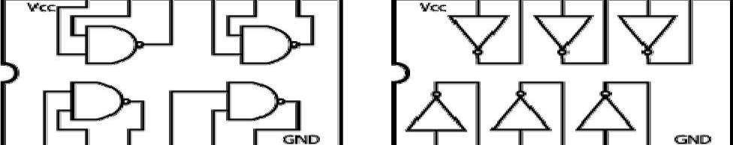

Quad 2 Input 7400 Hex 7404 Inverter

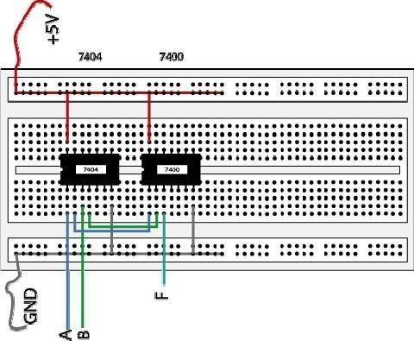

Sometimes the chip manufacturer may denote the first pin by a small, indented circle above the first pin of the chip. Place your chips in the same direction, to save confusion at a later stage. Remember that you must connect power to the chips to get them to work.

Some useful ICs are as follows.

|  |  |
| --- | --- |
| **NUMBER** | **cription of IC** |
| 7400 | Quad2inputNANDGATE |
| 7401 | Quad2inputNANDGate (open collector) |
| 7402 | Quad 2 input NOR Gate |
| 7403 | Quad2inputNORGates (open collector) |
| 7404 | Hex Inverts |
| 7421 | Dual 4 input AND Gates |
| 7430 | 8 input NAND Gate |
| 7432 | Quad 2 input OR Gates |
| 7486 | Quad 2 input EX-OR Gate |
| 74107 | Dual j-k Flip Flop |
| 74109 | Dual j-k Flip Flop |
| 74174 | Hex D Flip Flop |
| 74173 | Quad D Flip Flop |
| 7473 | Dual j-k Flip Flop |
| 7474 | Dual D Flip Flop |
| 7475 | Quad Bi-stable latch |

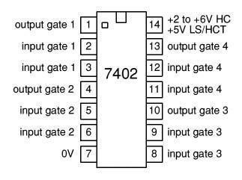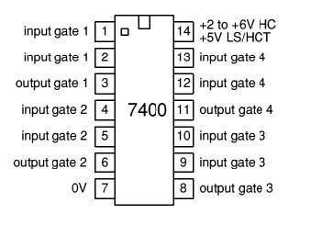

**Lab Task:**

Perform and verify all logic gates on Digital Logic Trainer.

**AND GATE:  
Circuit Diagrams:**

**Observations/Truth Table**

|  |  |  |
| --- | --- | --- |
| **A** | **B** | **Y=A.B** |
| 0 | 0 | 0 |
| 0 | 1 | 0 |
| 1 | 0 | 0 |
| 1 | 1 | 1 |

**OR GATE:  
Circuit Diagrams:**

**Observations/Truth Table**

|  |  |  |
| --- | --- | --- |
| **A** | **B** | **Y=A+B** |
| 0 | 0 | 0 |
| 0 | 1 | 1 |
| 1 | 0 | 1 |
| 1 | 1 | 1 |

**NOT GATE:  
Circuit Diagrams:**

**Observations/Truth Table**

|  |  |
| --- | --- |
| **A** | **Y=A’** |
| 0 | 1 |
| 0 | 1 |
| 1 | 0 |
| 1 | 0 |

**NAND Gate:**

**Circuit Diagrams:**

**Observations/Truth Table**

|  |  |  |
| --- | --- | --- |
| **A** | **B** | **Y=(AB)’** |
| 0 | 0 | 1 |
| 0 | 1 | 1 |
| 1 | 0 | 1 |
| 1 | 1 | 0 |

**Conclusion:**

In conclusion, this experiment successfully introduced the use of digital laboratory equipment, such as breadboards and ICs, while emphasizing the importance of proper circuit construction and safety precautions. By building and testing circuits for various logic gates, we gained hands-on experience with fundamental digital components like the 7404 NOT gate and others, verifying their functionality through truth tables. This practical approach solidified the understanding of basic logic gate operations and provided a foundation for more complex digital circuit design in future experiments.